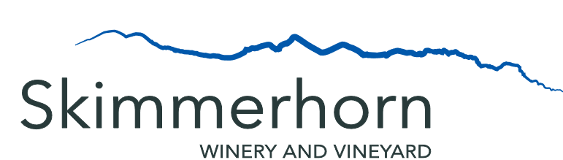

Menu
Quiche with Mixed Greens
$11.99
3 Dip Trio
$14.99
Your choice of
Any 3 Dip and Any 3 Side
Hummus Naan
Antipasto Baguette
Tzatziki Gluten Free Crackers
Olives Assorted Crackers

Veggie and Dip
$6.99
Nuts
Assorted
$6.99
Dessert
Foch Macaroons
$3.50
Porter Chocolate Cupcakes
$2.00

Wine
Complimentary Tasting of 4 Wines
(excluding Reserves)
Free
Glasses
White 6oz - $9
3oz - $4.50
Red 6oz - $10
3oz - $5
Flights – Choice of 3 Wines - $14
(excluding Reserves)
3 x 3oz Pours
Skimmerhorn Port Style Foch (SPF17) - $5.50
3 oz Glass
Beer
Wild North Brewing Lager (473mL) - $9
Wild North Brewing Hazy IPA (473mL) - $9
Wild North Brewing Golden Ale (473mL) - $9

Bottles on the Patio
Rose - $27
White - $25
Reds - $28
Reserves - $32

