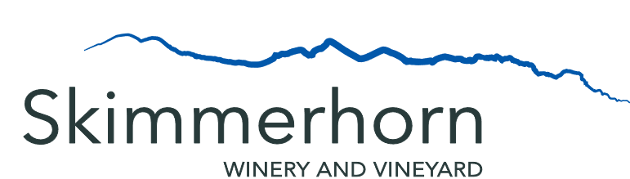

Menu
3 Meat and 3 Cheese Charcuterie Board
3 cuts of local meat, 3 assortments of local cheese,
pepper jelly, pickles, fruits, nuts, veggies, baguette, and assorted crackers
$29.99
3 Cheese Board
3 assortments of local cheese, baguette, assorted crackers,
pickles, fruit, nuts, veggies
$19.99
3 Dip Trio
$14.99
Your choice of
Any 3 Dip and Any 3 Side
Hummus Naan
Antipasto Baguette
Tzatziki Gluten Free Crackers
Olives Assorted Crackers

Veggie and Dip
$5.99
Nuts
Assorted
$5.99
Dessert
Foch Macaroons
$2.99
Porter Chocolate Cupcakes
$1.49

Wine
Complimentary Tasting of 4 Wines
(excluding Reserves)
Free
Glasses
White 6oz - $8.5
3oz - $4
Red 6oz - $9.5
3oz - $4.5
Flights – Choice of 3 Wines - $12
(excluding Reserves)
3 x 3oz Pours
Skimmerhorn Port Style Foch (SPF17) - $5
3 oz Glass
Beer
Wild North Brewing Lager (473mL) - $9
Wild North Brewing Hazy IPA (473mL) - $9
Wild North Brewing Golden Ale (473mL) - $9

