Bistro  Charcuterie and Cheese Board:  Our selection of cured and smoked meats, local and house-made cheeses  Comes with house bread and pickles  (GF upon request)  2 meats and 2 cheeses  3 meats and 3 cheeses  Blistered Shishitoes Peppers  A classic Spanish tapa with smoked paprika aioli V/GF  Thai Style Cucumbers  Hakuri salad turnips, toasted sesame, sweet & spicy chili sauce V (vegan)  Shaved Kohlrabi & Fennel Salad  Santa Rosa cherries, sweet Bavarian mustard vinaigrette V/GF (vegan)  Sweet Beet Salad  Poached beets, mixed greens, honey orange vin, lemon ricotta V/GF  Charred Broccoli  Cartwheel Farms broccoli, double smoked bacon, black pepper bechamel  Roasted Romanesco  Caramelized onion labneh, sugar snap peas, harissa V/GF  Patatas Bravas  New Warba potatoes, tomato chili jam, roasted garlic aioli V/GF  Macedonian Style Feta  House made soft and creamy Feta, Bumblebee tomatoes, basil oil, sour cherry balsamic V/GF  -add bread for $3.00 | $20  $28  $6.5  $7  $7  $8  $9  $10  $9  $12 | K | Alpindon Polenta  Creamy corn polenta, Alpindon cheese, Peperonata V/GF  Crispy Rabbit (Schnitzel)  Panko crusted fried Rabbit terrine, apricot chutney, mustard frisee  Mushroom Gnocchi  Blue Oyster mushrooms, pillowy Parisian gnocchi, Nostrala cheese, crispy sage V  Desserts  Apricot Cake  Faraman Farm apricots, Genoise, crème anglaise V  Pot de Crème  Dark chocolate custard, dulce de leche  GF/V  *Items on our menu may be subject to  change due to seasonal availability*  V= Vegetarian GF= Gluten Free  We politely decline any substitutions.  Please inform your server of any dietary restrictions/allergies before ordering.  Executive Chef – Maria Aryan  Our menu proudly features products from the following local suppliers: Cartwheel Farms, Famous Fritz, Faraman Farms, Kootenay Meadows, Swan Valley Honey, Treasure Life Flour Mills, Lark Coffee Roasters, Kootenay Natural Meats, Yaqan Nukiy Farms, Wloka Farms, Brittany’s Flower Farm, Sunshine Valley Organics, Mountain Valley Mushrooms, Thistle Farm, Creston Valley Farmers Market | $12  $14  $13.5  $8  $9
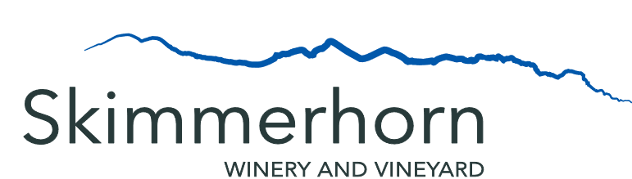

Wine List  Whites  2020 Pinot Gris  2020 Ortega  2020 Kootenay Crush  2020 Autumn Tryst  Rose  2020 Pinot Noir Rose  Reds  2019 Marechal Foch  2019 Devil’s Chair  Reserves  2019 Marechal Foch Reserve  Cider  Skimmerhorn Apple Cider  Skimmerhorn Sparkling Cider  Skimmerhorn Spritz  Fruit based cocktail made with Skimmerhorn  Eau de Vie  (Please ask server for seasonal flavour)  Port- Style Fortified Wine  SPF17  Skimmerhorn Port Style Foch  Beer  Wild North Brewing Lager (473mL)  Fernie Brewing Project 9 Pilsner  Nelson Brewing Campout Summer Ale  Non-Alcoholic Beverages  Local Apple or Cherry Juice  Lark Coffee – Vineyard Blend  (decaf available)  Granville Island Tea Company- Single Estate Ceylon  Local Organic Mixed Mint Tea  House-Made Soda  (ask your server for this week’s flavour) | Glass  $8.00  $8.00  $8.00  $8.00  $8.00  $9.00  $9.50  $9.50  N/A  $7.00  N/A  $8.00  $5.00  $10.50  $8.00  $8.00  $4.50  $6/$13  $6  $4  $4 | Bottle  $24.00  $24.00  $24.00  $24.00  $24.00  $24.00  $26.00  $26.00  $29.00  $18.00

