Bistro  Charcuterie and Cheese Board:  Our selection of cured and smoked meats, local and house-made cheeses  Comes with house bread and pickles  (GF upon request)  2 meats and 2 cheeses  3 meats and 3 cheeses  Sweet Beet Salad  Poached baby beets, mixed greens, honey orange vin, lemon ricotta V/GF  Grilled Caesar Salad  Mini Romaine lettuce, double smoked bacon, roasted garlic caesar dressing Nostrala cheese GF  Kohlrabi Pave  Carmelized onion Labneh, French breakfast radish, bronze fennel V/GF  Charred Broccoli  Cartwheel Farms sprouting broccoli, scallion ginger sauce V/GF (vegan)  Sutcliffe Farm Asparagus  Fresh Asparagus, Porcini mushroom butter, Labneh, crispy Alpindon cheese V/GF  Pearl Oyster Mushrooms  with pan fried spinach Spätzle, lemon ricotta V  Macedonian Style Feta  House made soft and creamy Feta, charred Shishito peppers, sugar snap peas, basil and tomato oil, sour cherry balsamic V/GF  -add bread $3.00 | $20  $28  $8  $9.5  $9  $8.5  $10  $12  $11.5 | K | Crispy Pork Schnitzel  Crispy pork schnitzel, sweet pepper aioli  Parisian Gnocchi Carbonara  House-made pillowy Gnocchi, double  smoked bacon, Onsen egg, Alpindon cheese  Tostada “al Pastor”  succulent roast pork, polenta tostada, pickled peaches, chipotle aioli, salsa verde GF  Desserts  Erdbeertorte  German strawberry cake with vanilla cheesecake filling V  Pot de Crème  Dark chocolate custard, dulce de leche  GF/V  *Items on our menu may be subject to  change due to seasonal availability*  V= Vegetarian GF= Gluten Free  We politely decline any substitutions.  Please inform your server of any dietary restrictions/allergies before ordering.  Executive Chef – Maria Aryan  Our menu proudly features products from the following local suppliers: Cartwheel Farms, Famous Fritz, Faraman Farms, Kootenay Meadows, Swan Valley Honey, Treasure Life Flour Mills, Lark Coffee Roasters, Kootenay Natural Meats, Yaqan Nukiy Farms, Wloka Farms, Brittany’s Flower Farm, Sunshine Valley Organics, Mountain Valley Mushrooms, Thistle Farm, Creston Valley Farmers Market | $14  $13.5  $14.5  $8  $9
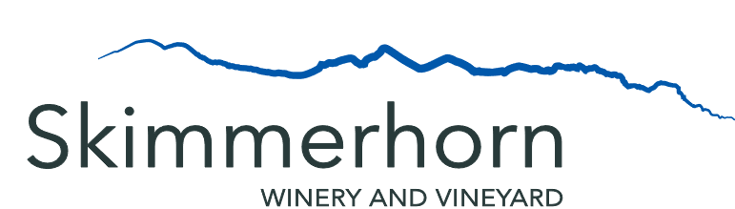

Wine List  Whites  2020 Pinot Gris  2020 Ortega  2020 Kootenay Crush  2020 Autumn Tryst  Rose  2020 Pinot Noir Rose  Reds  2019 Marechal Foch  2019 Devil’s Chair  Reserves  2019 Marechal Foch Reserve  Skimmerhorn Spritz  Fruit based cocktail made with Skimmerhorn  Eau de Vie  (Please ask server for seasonal flavour)  Port- Style Fortified Wine  SPF17  Skimmerhorn Port Style Foch  Beer  Fernie Brewing Project 9 Pilsner  Nelson Brewing Campout Summer Ale  Bowen Island Artisan IPA  Non-Alcoholic Beverages  Local Apple Juice  Lark Coffee – Vineyard Blend  (decaf available)  Granville Island Tea Company- Single Estate Ceylon  Local Organic Mixed Mint Tea  House-Made Soda  (ask your server for this week’s flavour) | Glass  $8.00  $8.00  $8.00  $8.00  $8.00  $9.00  $9.50  N/A  N/A  $8.00  $5.00  $8.00  $8.00  $8.00  $4.50  $6/$13  $6  $4  $4 | Bottle  $24.00  $24.00  $24.00  $24.00  $24.00  $24.00  $26.00  $26.00  $29.00

